IARC Problem Statement

Challenge is to build a fully autonomous flying bot which has to fly approximately 3kms while carrying a communications module of approximately 2kgs. It has to replace the current module with the module it is carrying.

**OBJECTIVES:**

1. The bot has to take-off and fly at less than an altitude of 15m to a distance of 3km.
2. The bot will then remove the communication module from the vessel which is located near the mast.
3. It will replace the module with the communications module payload it is carrying
4. After replacing the module, it will trace its return path back to the take-off/landing zone.
5. The complete operation is to be done within 9 minutes

**TASK OF THE BOT:**

1. Fly fully autonomously
2. Use ONLY onboard computing (no data links except for kill switch and safety pilot override)
3. Avoid obstacles including
4. Other aerial robot
5. Physical obstacles
6. Conduct the mission successfully and return home in under 9 minutes

**AERIAL ROBOT DESIGN DETAILS:**

1. The aerial robot must be fully autonomous and capable of performing all aspects of mission without human intervention
2. The vehicle must be self-contained (no off-board computing) and must have endurance exceeding 9-minute run time.
3. Obstacle avoidance must be incorporated into the design. Obstacles could be physical items on the ground or other aerial robots in the air.
4. The robot must self-navigate using GPS, visual cues, or magnetic headings.
5. The aerial robot can be of any configuration and can be compromised of “mother-ship” and expendable air-launchable sub-vehicles if desired. Propulsion can be electric or fossil fuel. Rocket propulsion or ballistic propulsion is prohibited.
6. The combined aerial robotic system must weigh less than 90kgs.
7. The aerial robot must be able to find the module based on its bright blue color and the words **“модули иртибот”** written above the module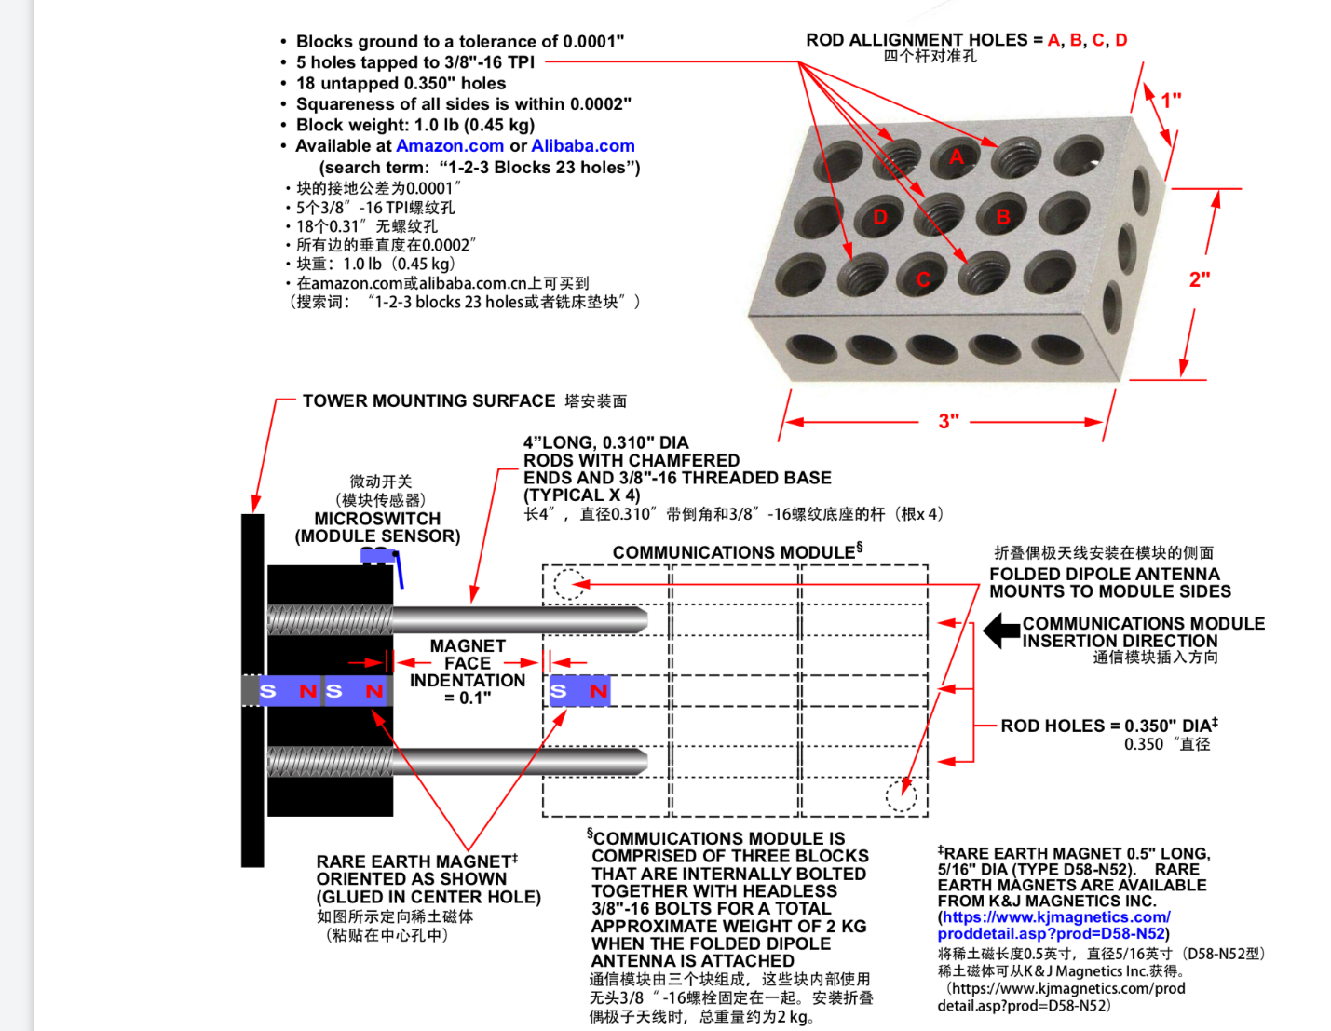

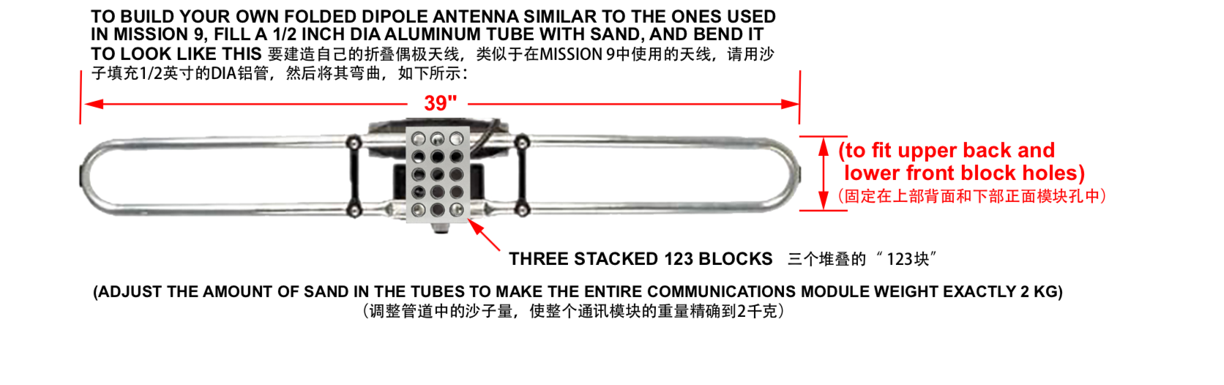

1. The aerial robot has to grasp the existing module, replace by pulling it off its mount, and install the new communications module on the same mounting point.
2. Upon completing the tasks, the robot must return to its launch point and land using its original ingress path.
3. The module is located on a triangular tubular mast in proximity to a rotating radar antenna and various obstacle such as whip antenna and flags.
4. Everything will be moving semi-randomly since the ocean waves cause the Hunter-Killer Vessel to pitch and roll. The vessel will be stationary in water at the time of your arrival.
5. A safety pilot can override the robot’s autonomous flight. But doing so will terminate the run. In addition, an independent “kill switch” must be supplied to the judges.
6. The kill switch will be able to render the aerial robot completely. “Independent” means the kill switch will have its own transmitter and will not use the vehicle’s on-board computer o process the kill command.
7. The kill switch will have to be demonstrated to the judging staff before teams are allowed to fly.

**THE ARENA:**

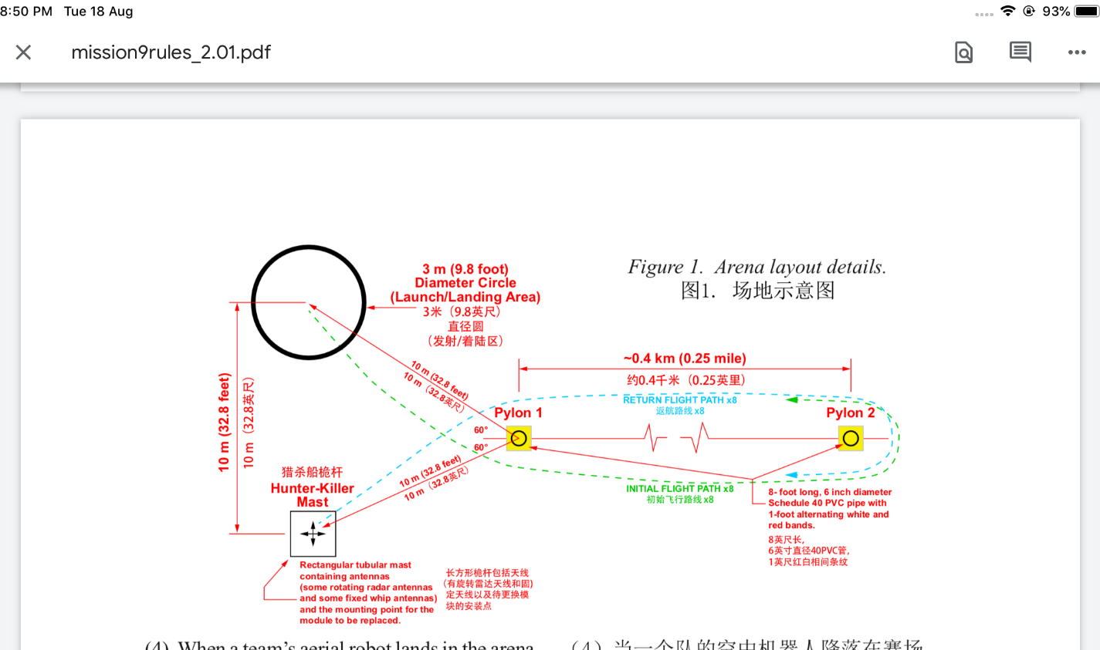

1. The arena will be an open outdoor area of undefined length and width. Within the arena, there will be the communication mast of the Hunter-Killer Vessel.
2. The launch pad will be a 3m diameter white circle approximately 10m to one side of the simulated Hunter-Killer mast.
3. To compress the linear distance of the arena, two pylons separated by approximately 0.4km will serve as “loop back” point. The approximate 3km course will be broken to 8 laps between the pylon.
4. The aerial robot will take-off near the Hunter-Killer mast, make 8 laps of the pylon, complete the communications module replacement and return by making 8 orbital laps of the pylon to land at the take-off location

**PICKING MECHANISM:**

We can use three jaw grippers for removing the communication module